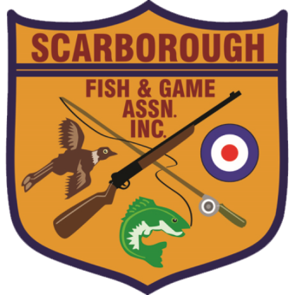

**Sunday, August 25, 2024**

RE: Downeast Regional Challenge & The Showdown – “The Beast of the East”

On behalf of the Scarborough Fish & Game Association, you are cordially invited to attend the NRA Registered Downeast Challenge Regional Mid-Range & F-Class Regional Championship (NRA Registered) and The Showdown – “Beast of the East”. The Two-day Match will be held October 12th and October 13th, 2024 at Scarborough Fish & Game Assoc., Scarborough Maine. The Showdown – “Beast of the East” will be a double elimination Match held on Monday, October 14th, 2024.

Regional: <https://scarfg.org/event/nra-registered-midrange-3x600-downeast-regional-challenge-2-day/>

The Showdown: <https://scarfg.org/event/the-showdown-beast-from-the-east-new-england-vs-maritimes-bracket-finale/>

Charlie Largay  
Rifle Chairman   
sfga.rifle@gmail.com